The following Event Operations and Safety Management Plan is a template and must include at the very least the following information.
All information provided in this template is an example – please edit accordingly to your event.

Note: Your completed Operations and Safety Management Plan is for you and your event kaimahi. Ensure this document is shared and discussed with your kaimahi ahead of the event, on the day and is utilised during the event, to ensure adequate health and safety at your event.

BACKGROUND
Provide a background of the event and what it is all about.

- INTRODUCTION
Event Name:
Event Date/s:
Contingency Date/s:
Event Location/s:
Event Start Time/s: | Registration: |  |  |  | Race Start:
Event Numbers: | Competitors (total):
 | W1: | W2: | W3: | W4: |  | W6: | W12:
 | Spectators:
Event Support Boats: | e.g. 1 Lead Boat, 1 Chase Boat + 3 support boats (5 in total). Use support boat calculator provided here
Event Tides Times: | Low Tide: |  |  |  | High Tide:
Event Outline: | What races, waves, distances, and divisions are you having?

- EVENT/RACE MAPS
Use Google Earth to help create course maps.

MAP 1: Main Racecourse (Include maps of racecourse here)
e.g. a picture of main race course
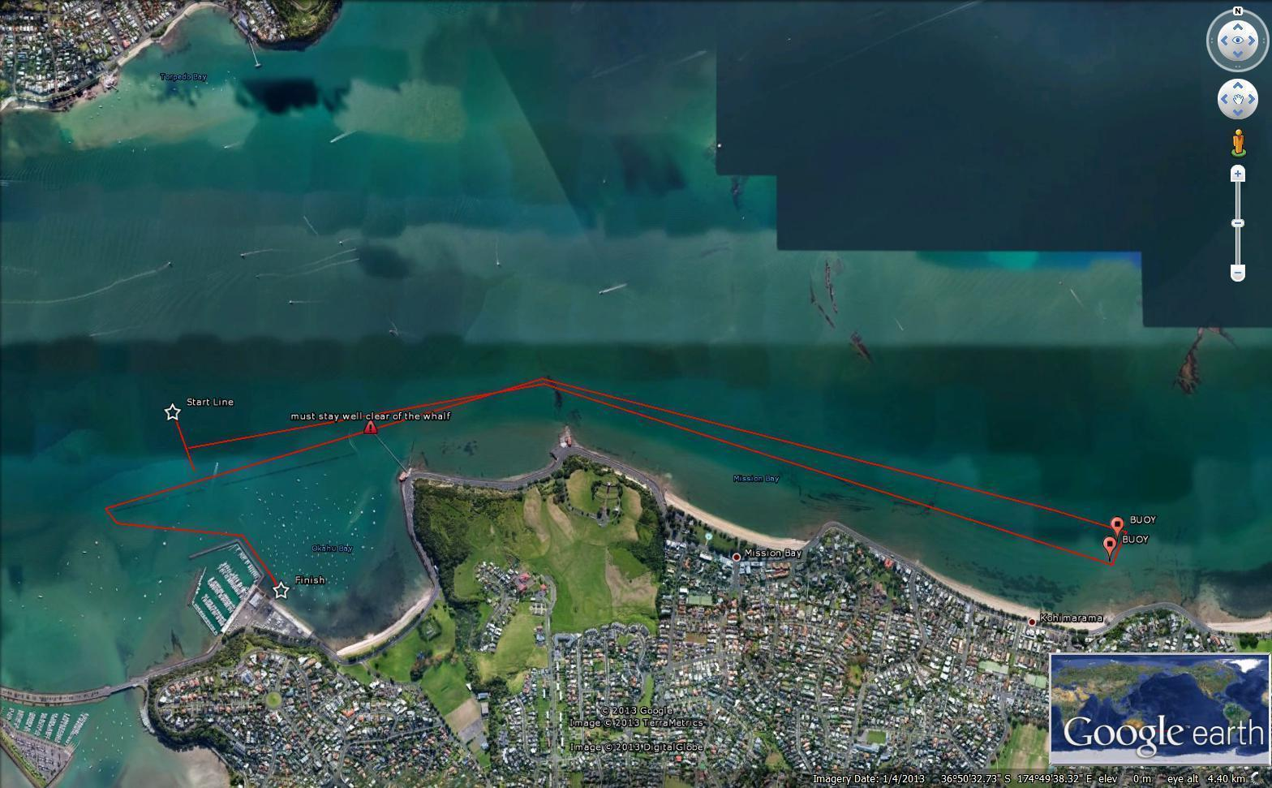

MAP 2: Alternative Racecourse/s (Include maps of alternate racecourse/s in case of bad weather here)
e.g. a picture of 4 separate course options, so that weather can be considered on the day.

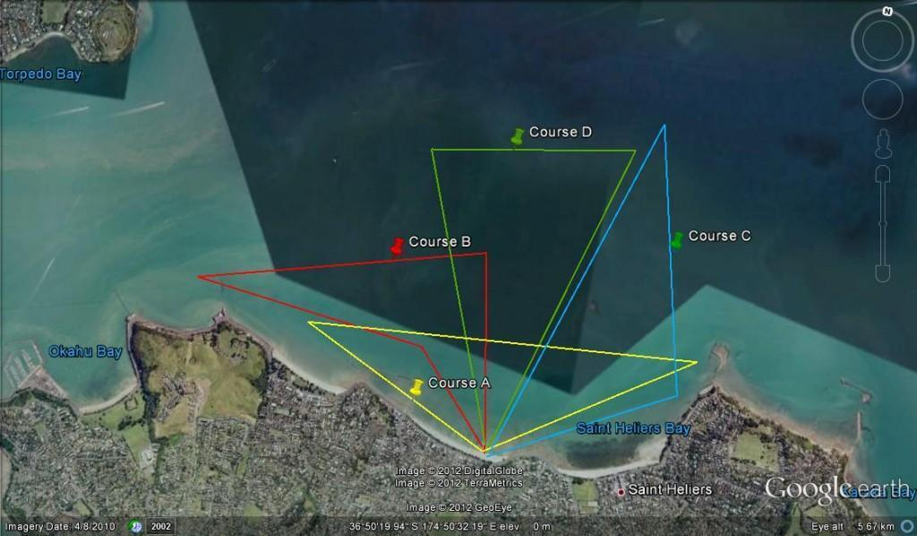

MAP 3: Courses on Marine Charts (Include your course maps on Marine Charts here)
e.g. a picture of courses on marine charts. (some harbour masters require this)

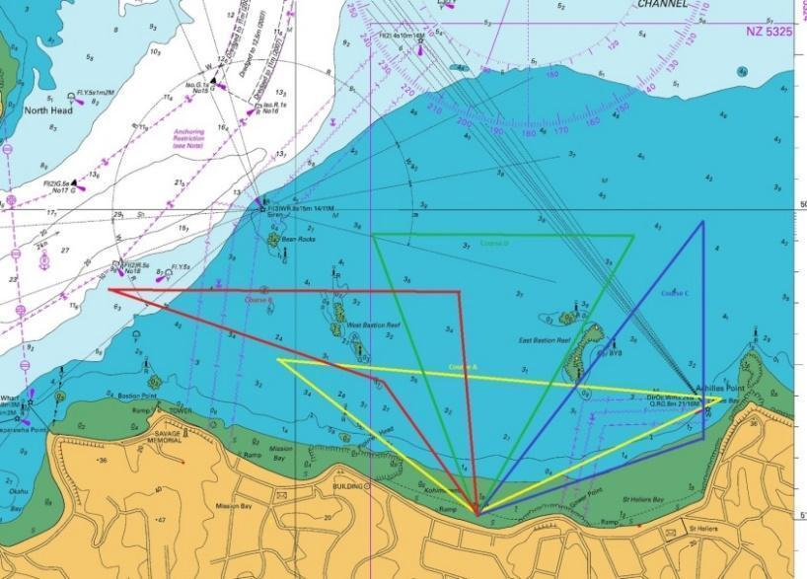

- RISK ASSESSMENT

The purpose of this part of the safety plan is to undertake a comprehensive risk assessment to determine support/safety boat and medical support requirements and form part of an effective event decision making protocol and communication to all participants.

3a: ‘Environmental’ Risk Assessment Edit according to your event.

Past experience for the same or similar events | Write here prior experience with this event and the possible conditions
Anticipated number of competitors | e.g. 100 People
Length of the course/s | e.g. 3.5km
Design of the course/s | e.g. Triangle
Proximity of the course to land | e.g. Less than 2km from shore
Anticipated wave / surf size | e.g. Less than ½ metre – 1 metre expected (maximum)
Assessment of paddlers ability | e.g. Competitors abilities range from novice to experienced paddlers
Any pre-entry qualifying criteria | read and edit accordingly  - All competitors must complete and sign a waiver, any paddlers U18 must have a parent/guardian sign  - All competitors must be fit and competent of completing the course, and must disclose any relevant medical conditions in the waiver form  - The safety briefing will cover the course, local weather patterns, tide times, wind direction and the likely effects on paddlers  - The safety briefing will cover how to raise assistance in an emergency, safe launching and exiting from the water, and safe beaching of Waka  - All competitors must have a life jacket  - All competitors must be fit and competent of completing the course  - All Waka must complete a safety check
Start / finish area | e.g. The Start Finish line will be in the Water Parallel with Shore
Water temperature | e.g. Expected to be approx 14 to 16 degrees
Event apparel worn during event | e.g. Club Uniform tops, no Jeans, Tracksuit pants etc
Weather and tide / current conditions | Write tide times here
Water quality assessment | e.g. Water Quality in the area is good. The water quality will be checked as close as possible to the event.
Other considerations | read and edit accordingly  Safety Requirements:  - All Competitors must have the waiver explained to them  - All competitors must sign a waiver confirming that they are able to swim  - All competitors must be fit and competent of completing the courses, and must disclose any relevant medical conditions in the waiver form  - The event course will be printed and on clear display at the registration table  - Experienced skippers and rescue craft will be on the course during the event - Safety craft will be on the water as outlined in the safety boat calculation. Boats will be in VHF communication with an onshore race director  - Safety Boats will have their own safety briefing prior to the race.  - Qualified First Aid personnel will be onsite  - Each boat has ample lifejackets, first aid equipment, cell phone in a waterproof case, and emergency flare onboard  - All starters and finishers will be counted (compulsory sign in and sign out)  - A system for reporting withdrawal from the race (DNF) – will be adopted.  - Cut-off times will be explained to paddlers  - Extreme weather conditions such as high wind and/or rain that jeopardise the safety of paddlers may lead to cancellation of the race. Event organisers will endeavour to inform all entrants of this by email or phone, or on the day at the event if adverse weather conditions arrive close to the expected start time.

RISK MANAGEMENT PLAN

Edit details according to your event

Equipment Management
Risk:  What could go wrong? | Cause | Prevention:  Eliminate/ Isolate/ Minimise | Equipment | Check  (tick) | Who is responsible? | Eliminate, Isolate, Mitigate
Vandalism | Graffiti, Damage to Property and Buildings | Monitor throughout day | Police |  | Event manager | M
Damage | To equipment, cars, public property, canoes etc… | Public Liability cover for any damage to property of the third party, including cover for illness from water drinking sources, serious injury or death of officials. |  |  | Event manager | M
Support Boat damage, not starting | Support boat engine failure, damage during travel | Ensure safety boats have been used prior to event, have back up safety boats in plan, revise race schedule or cancel event if safety boats not adequate | Back up safety boats |  | Event Manager | M

Environmental Management
Risk:  What could go wrong? | Cause | Prevention:  Eliminate/ Isolate/ Minimise | Equipment | Check  (tick) | Who is responsible? | Eliminate, Isolate, Mitigate
Possible 30+ knot winds could put paddlers at risk | Weather | Cancel/postpone the event if the weather predictions are too dangerous for racing. |  |  | Event Manager | E
Wet / bad weather-causing race to be unsafe | Weather | Cancel/postpone the event if the weather predictions are too dangerous for racing. |  |  | Event manager / Water support (IRB, jet ski /boat drivers) | E
Tsunami warning | Weather | Ensure updates are readily available to race organisers and participants.  Cancel/postpone the event if the weather predictions are too dangerous for racing. |  |  | Event Manager | M

On-the-water Management
Risk:  What could go wrong? | Cause | Prevention:  Eliminate/ Isolate/ Minimise | Equipment | Check  (tick) | Who is responsible? | Eliminate, Isolate, Mitigate
Injury related to the race | Pulled Muscle, fatigue, exhaustion, Heart Attack | St Johns/doctors on site, ICE and ambulance.  Supports Boats aware of hazards and signs. | St John/MEDIC. Support Boats |  | Event manager / Onsite First aid | M, I
Paddler unable to continue | Person affected by alcohol, anxiety, inexperience, weather conditions etc | Support boats able to retrieve paddler and craft safely | Support boat, Tow rope, communication |  | Race Director./Support craft | I, M
Drowning | Canoe capsizing | Capsizing Eliminated by using Double Hull waka  All competitors to have a life jacket | Life Jackets |  | Event manager / Water support (IRB, jet ski /boat drivers) | M
Collisions | Collision between Waka and recreational vessel | Safety craft will be patrolling perimeter of the course, public notice and advisory, VHF radio broadcast by coastguard | Safety Boats |  | Event Organiser and safety boat crew | M
Injury related to race | Pulled muscle, fatigue, exhaustion, heart attack | St johns on site, ICE and ambulance. Support Boats aware of hazard and signs | M, I |  | Event Organiser and safety boat crew | M, I
Paddler unable to continue | Person affected by alcohol, anxiety, inexperience, weather conditions | Support boats able to retrieve paddler and craft safely | M, I |  | Race director and support boats | M, I
Crew separated from canoe | Weather, inexperienced | Lifejackets, Support & Safety Boats to recover crew member, advise Race Control, first aid to be administered. Safety clothing.
Underage paddlers | Inexperienced paddlers competing in a demanding long distance race | All paddlers must sign a Waiver stating they are over the minimum age for that particular race. Paddlers are required to supply their paddler ID on registration, which will identify their age.

Personnel Management
Risk:  What could go wrong? | Cause | Prevention:  Eliminate/ Isolate/ Minimise | Equipment | Check  (tick) | Who is responsible? | Eliminate, Isolate, Mitigate
Injuries to staff, volunteers or spectators | Running into something, pulling a muscle. Cut foot | First Aid Station, have ice available. | first aider |  | Event manager | I
Spectators causing trouble. | Alcohol, | Have someone constantly patrolling the area. Call police if there is any kind of trouble. | Cell Phone, Walkie Talkies |  | Event manager | I, M
Support Boat Driver unable to start boat | No petrol | Ensure support drivers have petrol for the day and communicate with them before the event | Petrol, boat, Cell Phone, Walkie Talkie |  | Event manager | E, I

- SAFETY REQUIREMENTS (Equipment and Personnel)

Edit details according to your event

Based on the risk assessment completed previously, personnel and equipment requirements will be determined for this event.
Note: The listed support boat calculation at the time of sanctioning is subject to change depending on the entries. If entries exceed the original estimated participant numbers, more support boats will be required. Alternatively, entries can be monitored and close early once capacity of participants relevant to support boats has been reached.

Use support boat calculator provided here

Equipment Required | Number required | Number of experienced personnel | Personnel Competencies
Inshore Rescue Boat (IRB) | Number | Number | Experienced drivers, knowledge of environment, basic first aid skills
Jet Ski | Number | Number | Experienced drivers, knowledge of environment, basic first aid skills
Support Boat (other) | Number | Number | Experienced drivers, knowledge of environment, basic first aid skills
 | Total number of support boats: | Total number of personnel:

Radios and other communication tools | Number  Each boat must have access to radio or VHF communication | N/A | VHF with on water safety. RTS between land management

- KEY CONTACTS

Name | Positions/Area | Contact Phone | Contact Email
 | Race Director
 | Event Manager
 | Safety Boat Manager

- COMMUNICATION PLAN

It is expected that there needs to be direct (radio) communication between:
- Race Director, Event Manager and Lead Driver
- Event Manager, Lead Support boat Driver and all other support boat drivers

It is expected that there is an indirect (arm signals, whistle and/or voice) communication ‘method’ established between the personnel who are on/in the water on Waka, or using a tube and any IRB(s) being used.
*** Ensure the communication methods in place for the event are communicated at the race briefing/s and with all event kaimahi.

- PRE START SAFETY COMMUNICATION TO PADDLERS

General Safety

Pre-Race Safety Briefing: (will change based on race – below is an example) Edit details according to your event

- The safety briefing will cover the course, local weather patterns, tide times, wind direction and the likely effects on paddlers AND the explanation of the Safety Waiver.
- All competitors must complete and sign a waiver, any paddlers U18 must have a parent/guardian sign. All competitors must be fit and competent to complete the course, and must disclose any relevant medical conditions in the waiver form.
- The safety briefing will cover how to raise assistance in an emergency, safe launching and exiting from the water
- Paddlers will follow marker buoys to direct paddlers of their correct path
- It should be made clear to all paddlers that the race director/organiser or the event personnel can stop any paddler from competing/completing if they show signs that they will not complete it in an acceptable time or acceptable condition
- The Course may be changed from earlier pānui based on the conditions and will be communicated at the briefing.
- There will be a process explained to all competitors should the race need to be stopped for any reason.
- Paddlers should be encouraged to hydrate, dress appropriately and apply sunscreen prior to the event starting
- All W6 Waka must carry 2 bailers & 6 life jackets, a tow rope 25m in length, a flare & communication device, a spare paddle and any other safety equipment
- All W1 Waka must carry a bailer and a life jacket, a flare and communication device, a spare paddle, and any other safety equipment
- All Waka Ama NZ Race rules apply

Cancellation/Postponement
Extreme weather conditions such as high wind and/or rain that jeopardise the safety of paddlers may lead to cancellation/postponement of the race. Event organisers will endeavour to inform all entrants of this by email the day before the events or as early as possible on the day.

- PRE START SAFETY COMMUNICATION TO SAFETY BOAT CREWS / EVENT KAIMAHI

Edit details according to your event
- A register of all personnel present on the day of the event should be taken
- The Event Manager or appropriately trained representative should:
- Run through all the safety and race instructions being given to the event paddlers
- Run through the risk assessment for the event
- Run through the role of the on water event personnel – support, rescue, first aid
- Run through the communication plan
- Outline what will happen in a rescue and/or emergency
- Outline the role of the personnel; at the start of the race, during the race, at the end of the race

- Personnel Wellbeing and Personal Safety. The Event Manager should also ensure that all event personnel have the right equipment. Event personnel should be wearing appropriate clothing for the conditions and they should wear a hat to protect from the sun and have sunscreen available to use. Event personnel should be adequately hydrated and fed for the event.

- ON-WATER SAFETY AND EMERGENCY MANAGEMENT

Edit the details below according to your event - what will you do in the case of an emergency?

In the case of an emergency on the water, the following safety management applies:
- A participant in distress will be approached by the closest available on-water support personnel when they raise their paddle, or are in obvious distress
- Event personnel will assess the severity of the situation and determine whether further assistance is needed. If not, then the paddler will head on their way
- If support is needed, then the personnel at the scene will respond to the emergency, administer first aid where required, and communicate directly with the race director and event manager. If emergency services are required this should be communicated at this point.
- If required, a call for more support boat(s) should be made and another assessment will be made by the second watercraft on arrival.
- The on-water safety boat manager should coordinate the remainder of the boats on the course to ensure paddlers are covered. If necessary, the race may be cancelled and paddlers be rounded up and taken to shore.
- All efforts will be made to commence first aid treatment – depending on conditions
- Event personnel will then transport the participant to the agreed emergency rendezvous point where an advanced paramedic will be stationed and ready to administer medical support
- In the event that an safety boat has to take a victim to a different rendezvous point the land based event manager will liaise with the medical staff
- Upon getting the emergency call from the water the advanced paramedic or primary care officers will ring for back up if needed and instruct additional ambulance and police to meet at the emergency rendezvous point
- Race number of participant reported to the event manager and all relevant information is gathered, including the participant/s event waiver
- Event personnel will continue first aid until it is suitable to hand over to the land based medical team
- Advanced paramedic or primary care crew to hand over to arriving ambulance paramedics if necessary
- Race numbers of all leaving the race reported to the event manager for counts and updated to water crew

The following minimum first aid resources will be available at the event:
- 1 x Event manager (with current First Aid certificate)
- Cell Phone
- At least 1 key personnel on land and 1 key personnel on water with Current First Aid
- Ice
- Defibrillator (or knowledge of Nearest one)
- On Call - 111 Ambulance

Resources will be positioned at the following locations:
- Start of the Event/Emergency Rendezvous point
At least 1 x Qualified First aider on the Water

- INCIDENT REPORTING
All incidents should be recorded immediately after the incident (see Template #12). This includes both on the water and off the water incidents that occurred during the event. All events should be communicated directly to the Event Manager/Race Director as soon as practically possible, but before the end of the event. This may include but is not limited to the following:
- Supporting a paddler on the water but allowing them to continue racing (notify name/number of paddler to Race Director)
- Withdrawing a paddler from the race and supporting them back to land (notify name/number of paddler to Race Director)
- Rescuing a paddler on the water, administering first aid, bringing them back to shore (notify name/number of paddler to Race Director)
- Emergency response to any serious incidents
- Response to all other on the water incidents and off the water incidents, including any first aid interventions

- POST EVENT DEBRIEF

There should be at least two formal levels of event debrief.

- The Event Manager should meet with all on water event personnel immediately following the completion of the event. Areas to cover will include, but is not limited to) an assessment of the risk factors, whether there was adequate on-water presence, and areas where improvement could be made. This is a good time for the Event Manager to ensure that the water crew are all okay (physically and emotionally) and thanked for their efforts.

- If there are other key authorities involved with the event, such as Harbour Master, Police etc. then they should be included in this meeting if required

The purpose of the de-brief is to run through all aspects of the event for the purpose of assessing the effectiveness of the planning for this event, and areas where improvements could be made for similar events to be held in the future.

Notes from these meetings should be recorded.

- INCIDENT REPORT TEMPLATE

The following template should be used for reporting all incidents at the event (see point 10 for more info). These should be discussed during the debrief.

Date: | Time:
Event:
Event Host:
Venue:
Incident Summary:

Actions taken:

General Comments/ Future reference:

Was there any first aid administered? Yes / No (If yes please provide details)

Was anyone involved in the incident required to seek further medical care? Yes / No (If yes please provide details)

Race/Safety coordinator Name:

Signature:

Date:

For any incidents that require further emergency response, please ensure communication is completed with them e.g. Harbour Master, Police, Ambulance, Waka Ama NZ. And is reported accordingly.

